Project Assignment 3

SYSTEM ANALYSIS ITRW 213

ay patel 27342514

RB De klerk 25007335

Nj roberts 25994689

fj verster 25021516

Analysis paralysis

2017

Table of Contents

Description of project and system requirements 2

Project Description 2

Requirements 2

Functional Requirements 2

Inputs: 2

Outputs: 2

Processes: 2

Stored data: 3

Non-functional requirements 3

Use Case List 4

Use case List 5

Sample High level version of the Use Case Narrative 6

Data Models 9

Context data model 9

Key-based data model 9

Fully attributed data model 10

CRUD Matrix 11

Process Models 12

Examples of prototype 13

# Description of project and system requirements

## Project Description

Chalique Nail Studio is a micro business in Johannesburg owned by two entrepreneurs who are in need of a new information system and are looking to expand in the future. Presently bookings and transactions are noted in a diary and all documentation and sales are done by hand. New stock is ordered manually as products are needed.

This project aims to design a system that is easy to use and simplifies the booking and sales processes. It also aims to aid in keeping better track of client’s details and backup systems.

## Requirements

This system has functional requirements consisting of inputs, outputs, processes and data storage as well as non-functional requirements based on the PIECES framework.

## Functional Requirements

### Inputs:

As shown in figure 1 the inputs for making an appointment include:

* Client name
* Time and date of the appointment
* Selection of treatments

For the sales section inputs will also include:

* Products used
* Cost of treatment

### Outputs:

As shown in figure 2 the outputs include:

* List of bookings ordered by day for a 5-day period
* Information of a selected booking including appointment and treatment details
* Options to add, edit and cancel bookings

Financial statement generated on demand with monthly, quarterly or yearly details.

### Processes:

* Add to and edit bookings in the database
* Add sales to a sales database
* Add clients to a clients’ database and edit details
* Stock management

### Stored data:

Clients table:

* Client name
* Client cell number
* Email address

Bookings table:

* Date and time of booking
* Treatments
* Cost
* Client name

Sales table:

* Treatments
* Payment method
* Booking reference
* Cost

Treatments table:

* Treatment description
* Products used
* Treatment cost
* Time required

Stock table:

* Product name
* Amount

Expenses table:

* Expense description
* Amount

## Non-functional requirements

Based on the PIECES framework:

* Access level for different users to prevent access to financial data by unauthorized users.
* No training required
* Budget:
  + Estimated salary of a system analyst per year: R 360 000
  + Breakdown: R170 p/h for 8-hours p/d 260-days p/y (Monday to Friday, 8-hour workday)
  + Estimated salary for entry level system analyst per year: R 310 000
  + Breakdown: R150 p/h for 8-hours p/d 260-days p/y (Monday to Friday, 8-hour workday)
  + Work time required: 2-hours p/d 5-days p/w for 36 weeks
  + Maximum Estimate: R150 p/h pp x 360 hours x 4 analysts = R 216 000
  + Minimum estimate: R 100 000.
* The development and implementation must be completed by 25 October 2017
* Easy to maintain

Figure 1: Proposed appointment input form

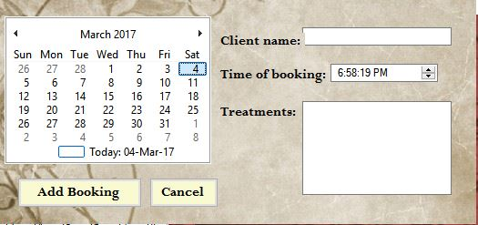Figure 1

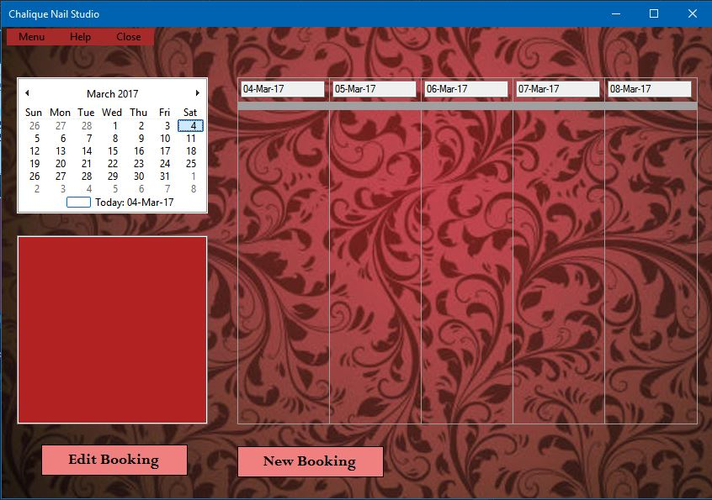*Figure 2: Proposed main form*

Figure 2

# Use Case List

## Use case List

|  |  |  |  |  |  |
| --- | --- | --- | --- | --- | --- |
| **Use Case I.D** | **Name** | **Primary Actor** | **Scope** | **Priority** | **Complexity** |
| UCI-001 | Make new booking | Client | In | High | Medium |
| UCI-002 | Edit booking | Client | In | Medium | Medium |
| UCI-003 | Cancel booking | Client | In | Medium | Low |
| UCI-004 | Add expense | Owner | In | High | High |

# Sample High level version of the Use Case Narrative

|  |  |  |  |  |  |  |  |  |  |
| --- | --- | --- | --- | --- | --- | --- | --- | --- | --- |
| **Authors:** | AY Patel NJ Roberts FJ Verster RB de Klerk |  |  | **Date:** | | 30-Mar-17 | | |  |
|  |  |  |  | **Version:** | | 1.0 | | |  |
|  |  |  |  |  |  |  |  |  |  |
|  |  |  |  |  |  |  |  |  |  |
| Use-Case Name: | Make new booking | | | | | Use-Case type  System Requirements: ☑ | | | |
| Use-Case ID: | UCI-001 | | | | |
| Priority: | High | | | | |
| Source: | Requirement - UCI-R1.00 | | | | |
| Primary business actor: | Client | | | | | | | | |
| Other participating actors: | Employee | | | | | | | | |
| Other interested stakeholders: | Owner --> Interested in booking activity to evaluate business performance and customer satisfaction. The owner is also interested to plan new promotions regarding marketing within the business | | | | | | | | |
| Description: | This use case describes the event of a client making a new booking at Chalique nail studio for a specific treatment. Details about the treatment are then recorded and a booking is made consisting of the time and price of the treatment. If the client wants to repeat bookings then they can schedule for those specific dates. After the appointment is complete, the client pays and receives a receipt and the payment is noted. | | | | | | | | |
|  |  |  |  |  |  |  |  |  |  |
|  |  |  |  |  |  |  |  |  |  |
|  |  |  |  |  |  |  |  |  |  |
|  |  |  |  |  |  |  |  |  |  |
| Use-Case Name: | Edit booking | | | | | Use-Case type  System Requirements: ☑ | | | |
| Use-Case ID: | UCI-002 | | | | |
| Priority: | Medium | | | | |
| Source: | Requirement - UCI-R2.00 | | | | |
| Primary business actor: | Client | | | | | | | | |
| Other participating actors: | Employee | | | | | | | | |
| Other interested stakeholders: | Owner --> Interested in booking activity to evaluate business performance and customer satisfaction. | | | | | | | | |
| Description: | This use case describes the event of editing a clients existing appointment at Chalique nail studio for a specific treatment. Details about the treatment are then updated and a booking is made consisting of the new time and price of the treatment. If the client wants to repeat bookings then they can schedule for those specific dates. After the appointment is complete, the client pays and receives a receipt and the payment is noted. | | | | | | | | |
|  |  |  |  |  |  |  |  |  |  |
|  |  |  |  |  |  |  |  |  |  |
|  |  |  |  |  |  |  |  |  |  |
| Use-Case Name: | Cancel booking | | | | | Use-Case type  System Requirements: ☑ | | | |
| Use-Case ID: | UCI-003 | | | | |
| Priority: | Medium | | | | |
| Source: | Requirement - UCI-R3.00 | | | | |
| Primary business actor: | Client | | | | | | | | |
| Other participating actors: | Employee | | | | | | | | |
| Other interested stakeholders: | Owner --> Interested in booking cancellations to evaluate business performance and customer satisfaction. | | | | | | | | |
| Description: | This use case describes the event of cancelling a clients existing appointment at Chalique nail studio for a specific treatment. Details about the treatment are then removed and the appointment is deleted. | | | | | | | | |
|  |  |  |  |  |  |  |  |  |  |
|  |  |  |  |  |  |  |  |  |  |
|  |  |  |  |  |  |  |  |  |  |
|  |  |  |  |  |  |  |  |  |  |
| Use-Case Name: | Add expenses | | | | | Use-Case type  System Requirements: ☑ | | | |
| Use-Case ID: | UCI-004 | | | | |
| Priority: | High | | | | |
| Source: | Requirement - UCI-R4.00 | | | | |
| Primary business actor: | Owner | | | | | | | | |
| Other participating actors: | Bank (Account) | | | | | | | | |
| Other interested stakeholders: | Government --> Interested in business profits in order to evaluate taxes. | | | | | | | | |
| Description: | This use case describes the event of paying all expenses that are incurred by the business. A report is generated for the total expenses for evaluation. | | | | | | | | |

# Data Models

## Context data model

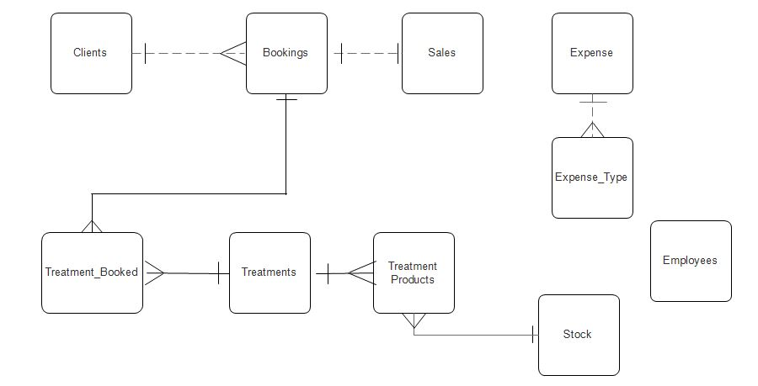

## Key-based data model

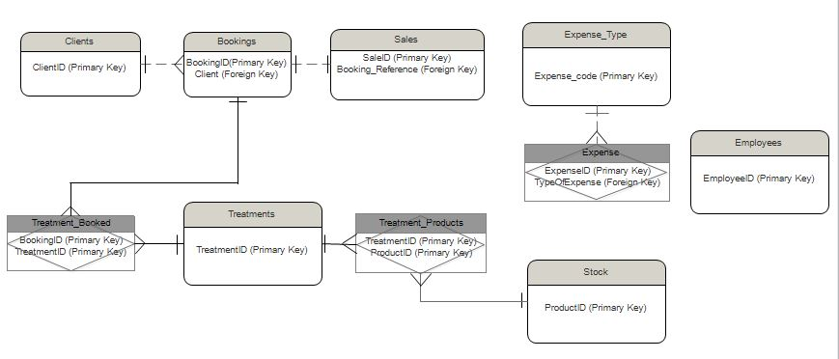

## Fully attributed data model

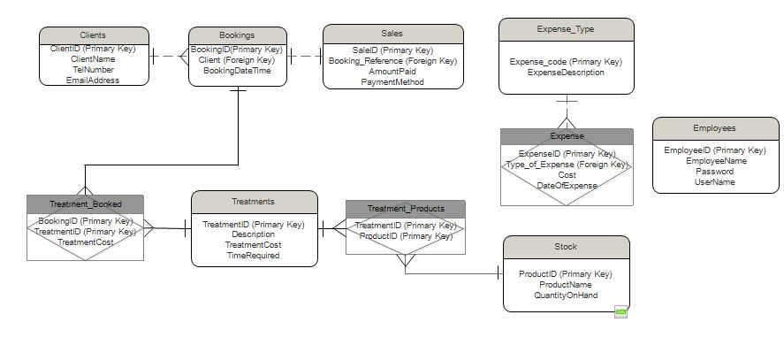

# CRUD Matrix

|  |  |  |  |  |  |  |  |  |  |  |
| --- | --- | --- | --- | --- | --- | --- | --- | --- | --- | --- |
| Entity. Attributes | Location | Clients | Johannesburg | . Services |  |  |  |  |  |  |
| Client |  | **INDV** |  | **ALL** |  |  |  |  |  |  |
| . Client I. D |  | R |  | CRD |  |  |  |  |  |  |
| . Client name |  | RU |  | CRUD |  |  |  |  |  |  |
| . Client email |  | RU |  | CRUD |  |  |  |  |  |  |
| . Client phone number |  | RU |  | CRUD |  |  |  |  |  |  |
| Booking |  | **INDV** |  | **ALL** |  |  |  |  |  |  |
| . Booking I. D |  | SRD |  | CRD |  |  |  |  |  |  |
| . Booking date/time |  | RUD |  | CRUD |  |  |  |  |  |  |
| . Treatment type |  | RUD |  | CRUD |  |  |  |  |  |  |
| Treatment |  | **ALL** |  | **ALL** |  |  |  |  |  |  |
| . Treatment I. D |  | SR |  | R |  |  |  |  |  |  |
| . Treatment Cost |  | URD |  | R |  |  |  |  |  |  |
| Services |  | **INDV** |  | **ALL** |  |  |  |  |  |  |
| . Payment method |  | S |  | R |  |  |  |  |  |  |
| . Amount paid |  | R |  | R |  |  |  |  |  |  |
| Stock |  | **INDV** |  | **SS** |  |  |  |  |  |  |
| . Product I. D |  | X |  | RD |  |  |  |  |  |  |
| . Product name |  | X |  | CRUD |  |  |  |  |  |  |
| . Product quantity |  | X |  | CRUD |  |  |  |  |  |  |
| Expenses |  | **INDV** |  | **SS** |  |  |  |  |  |  |
| . Expense I. D |  | X |  | R |  |  |  |  |  |  |
| . Date of expense |  | X |  | R |  |  |  |  |  |  |
| . Type of expense |  | X |  | CRUD |  |  |  |  |  |  |
| . Cost of expense |  | X |  | RUD |  |  |  |  |  |  |
|  |  |  |  |  |  |  |  |  |  |  |
|  |  | INDV = Individual | | ALL = all |  | SS = Subset | | X = no access | |  |
|  |  |  |  |  |  |  |  |  |  |  |
|  |  | S = Submit | | C = Create | | R=Read |  | U = Update | | D = Delete |

# Process Models

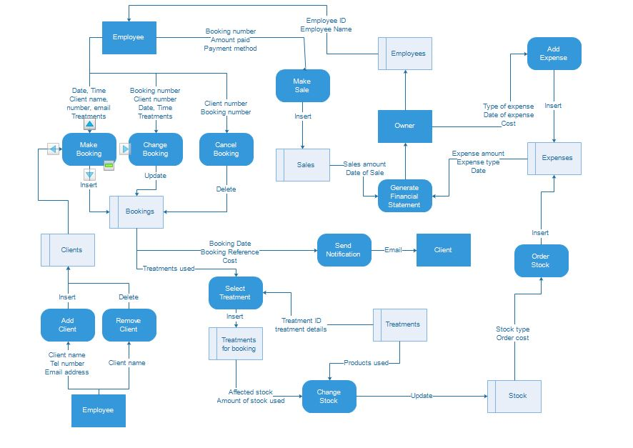

# Examples of prototype

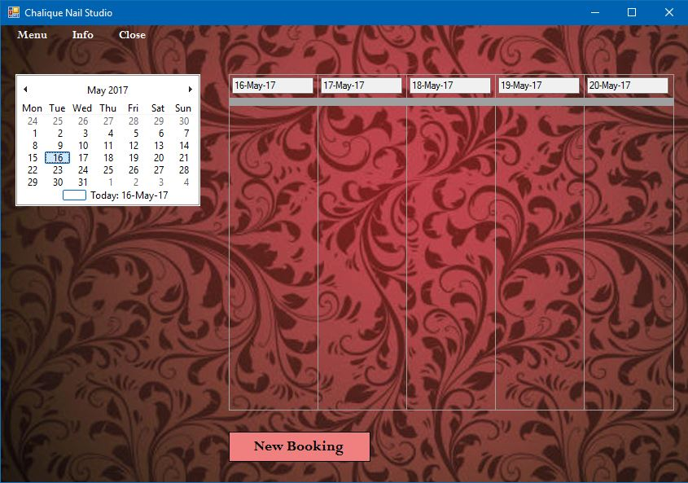

The main form to view all bookings and select bookings to interact with.

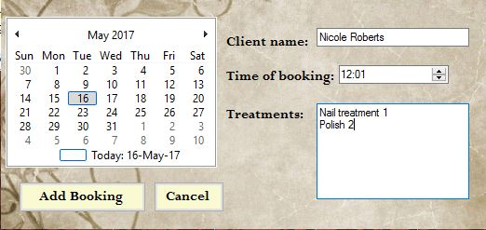

Form to add a new booking and edit existing bookings.